Setup visual studio community, its free to use maybe they want a mail address.
https://visualstudio.microsoft.com/de/downloads/

Then after the install it comes and asks for if you want to install any plugins.
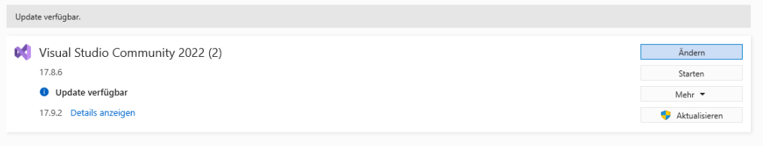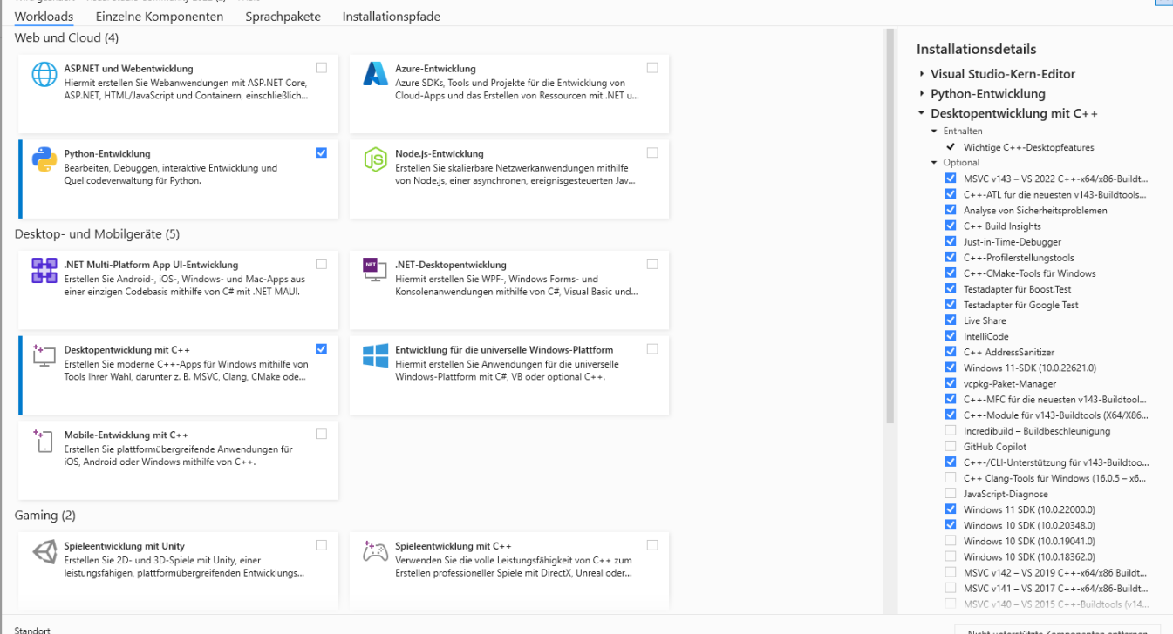

You need to have those packages installed within of visual studio that’s all, you’re done with visual studio here. Python is not needed its only there for me for some debugging.
Then you need to have the nvidia cuda SDK which you get here
https://developer.nvidia.com/cuda-downloads

the cuda has to be installed after visual studio, otherwise it will never work.

Last step is to pip install llama-cpp-python
You have to set the two environment variables and then use the pip install line from below

$Env:CMAKE_ARGS="-DLLAMA_CUBLAS=on"
$Env:FORCE_CMAKE="1"
pip install llama-cpp-python --force-reinstall --upgrade --no-cache-dir

Bonus, if you want torch to run on GPU just do this, it will work without any of the above steps
pip3 install torch torchvision torchaudio --index-url https://download.pytorch.org/whl/cu121

